**DAILY ONLINE ACTIVITIES SUMMARY**

|  |  |  |  |  |  |  |  |  |
| --- | --- | --- | --- | --- | --- | --- | --- | --- |
| **Date:** | **26-05-2020** | | | | | **Name:** | **Shiza Amreen.J** | |
| **Sem & Sec** | **4th sem B sec** | | | | | **USN:** | **4AL18CS078** | |
| **Online Test Summary** | | | | | | | | |
| **Subject** | | **Design And Analysis of Algorithms** | | | | | | |
| **Max. Marks** | | **30** | | **Score** | | | **26** | |
| **Certification Course Summary** | | | | | | | | |
| **Course** | **Python for Machine Learning** | | | | | | | |
| **Certificate Provider** | | | **GreatLearning** | | **Duration** | | | **5 Hours** |
| **Coding Challenges** | | | | | | | | |
| **Problem Statement:1.** [Write a program in C to print all permutations of a given string using pointers.](https://github.com/orgs/alvas-education-foundation/teams/2nd-year/discussions/81)  2. [Given an array A of size N where the array elements contain values from 1 to N with duplicates, the task is to find total number of subarrays which start and end with the same element.](https://github.com/orgs/alvas-education-foundation/teams/2nd-year/discussions/80) | | | | | | | | |
| **Status: Completed** | | | | | | | | |
| **Uploaded the report in Github** | | | | | **yes** | | | |
| **If yes Repository name** | | | | | **Lockdown_Coding** | | | |
| **Uploaded the report in slack** | | | | | **yes** | | | |

Online Test Details:

Today I had Design and Analysis of Algorithms IA-2, I have attended and scored 26 out of 30 and submitted it.

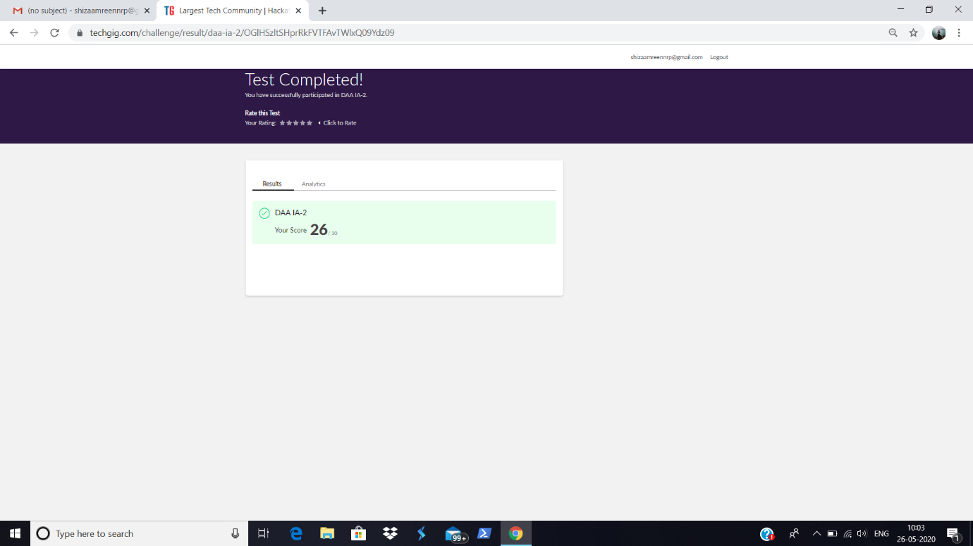

Certification Course Details:

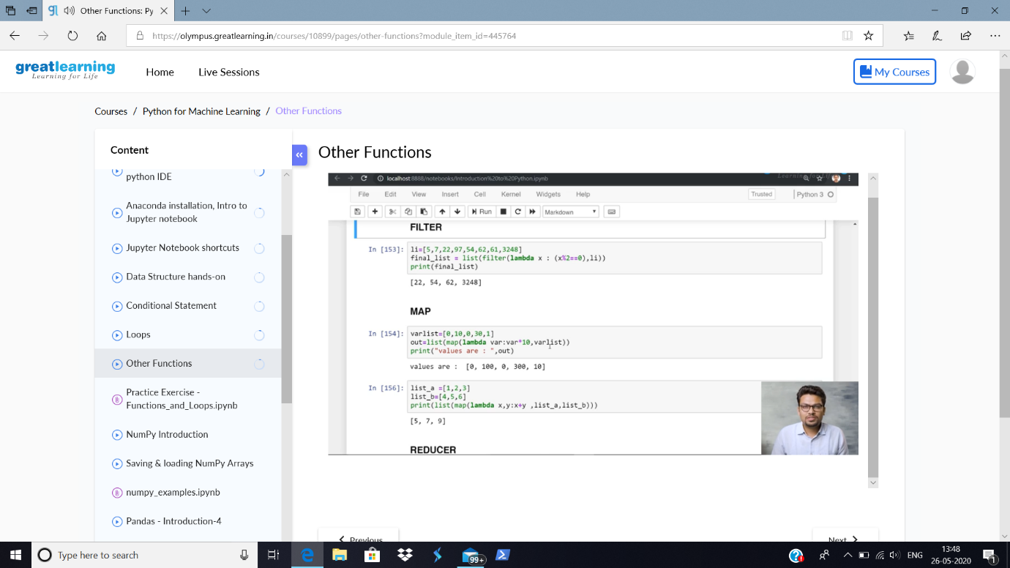

Today in the course, I have learnt about the others functions in python for Machine Learning, i.e., about usage of Lambda, Filter, Map and Reducer.

Coding Challenges Details:

**Problem Statement: 1.**[Given an array A of size N where the array elements contain values from 1 to N with duplicates, the task is to find total number of subarrays which start and end with same elements.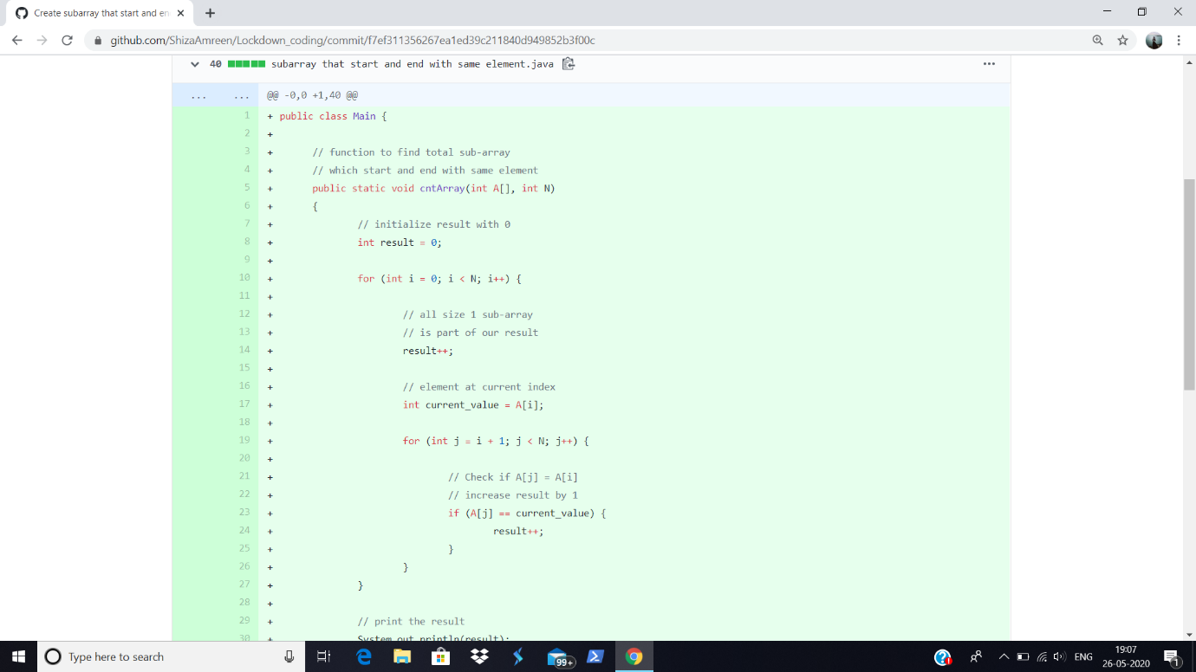](https://github.com/orgs/alvas-education-foundation/teams/2nd-year/discussions/80)

<https://github.com/ShizaAmreen/Lockdown_coding/blob/master/subarray%20that%20start%20and%20end%20with%20same%20element.java>

2. [Write a program in C to print all permutations of a given string using pointers.](https://github.com/orgs/alvas-education-foundation/teams/2nd-year/discussions/81)

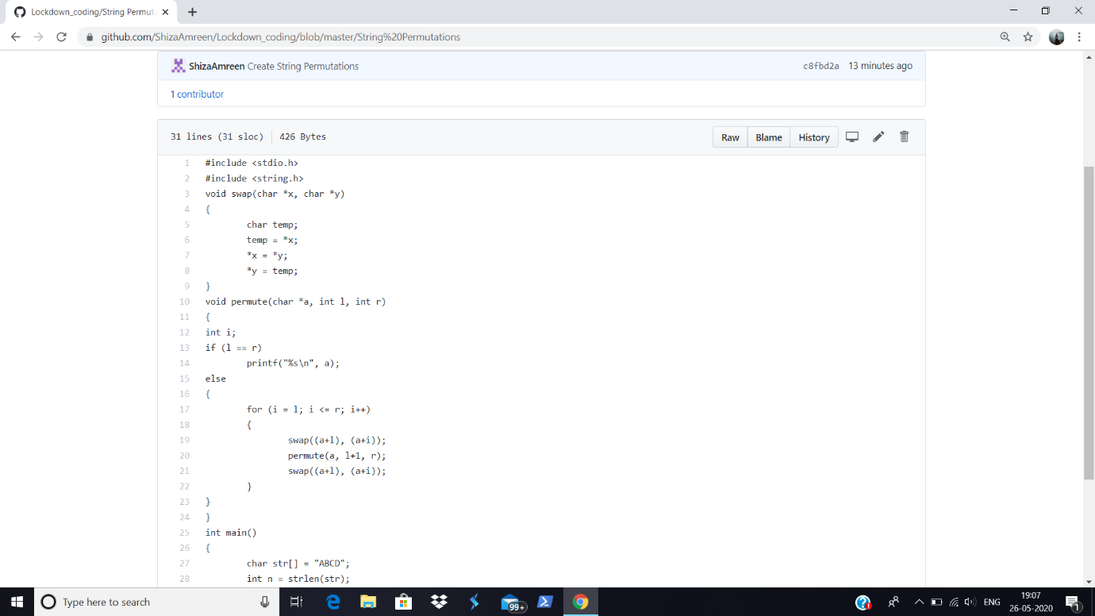

<https://github.com/ShizaAmreen/Lockdown_coding/blob/master/String%20Permutations>

I have written the code for the following problem statements and uploaded it in my github repository, Lockdown_Coding.